Department of Computing
CS220: Database Systems
Class: BSCS-15D, BSAI – 2A
Submitted By: Noor Fatima
CMS ID: 559891

Lab 02: SQL Operators
Task 1:
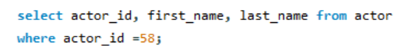
Output:
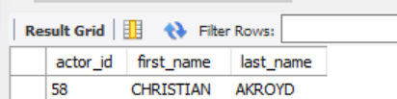
Task 2:
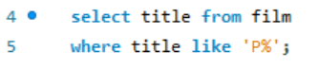
Output:
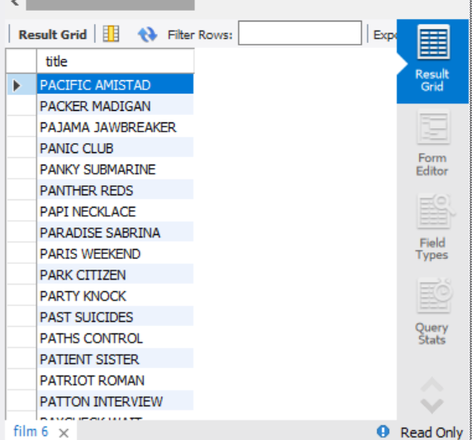
Task 3:
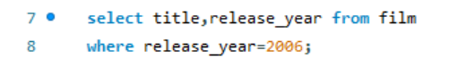
Output:
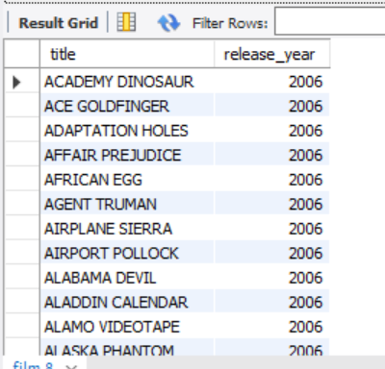
Task 4:
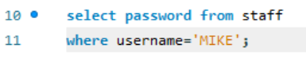
Output:
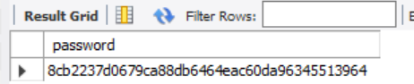
Task 5:
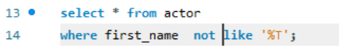
Output:
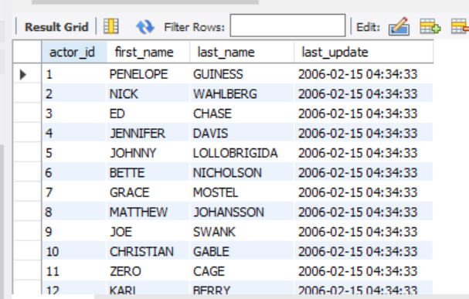
Task 6:
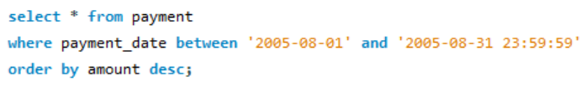
Output:
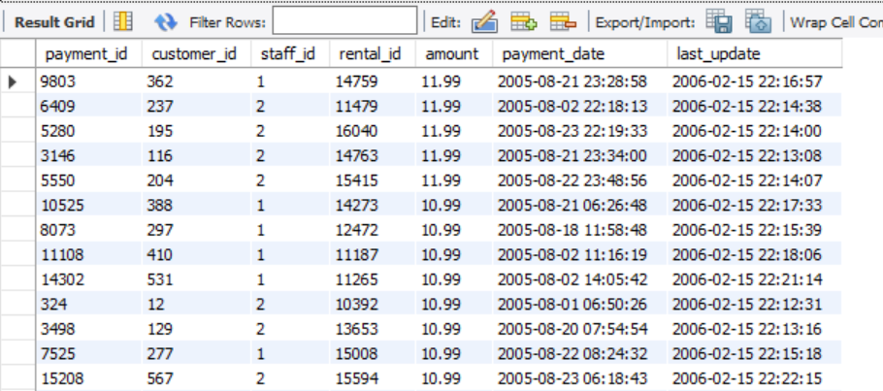
Task 7:
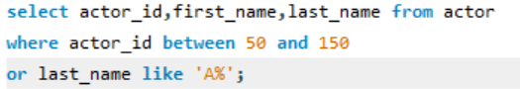
Output:
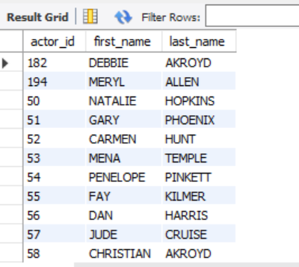
Task 8:
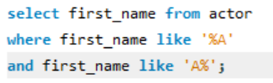
Output:
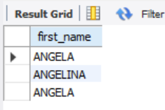
Task 9:
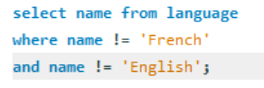
Output:
